Week #2 Lecture Notes

Chapter #3 Pointers and Array-based Lists

Pointers: In simple words, pointers denote memory addresses. Given a memory address, one can access/modify the data at that location. C language is the first one that introduced pointers to high level languages. Most geeks loved pointers since pointers brought additional power, flexibility, and efficiency to programming. All others hated pointers due to the higher complexity in design and debugging the programs that use pointers. A few people even have the following extreme view: Pointers are dangerous to use and they should be abolished from programming all-together. Now-a-days, most people believe that there is value using pointers in programming, but they should be used carefully.

Ok, let us get on with pointers. As the name suggests, pointers are used to point to something. More formally, pointer is a special variable that contains memory address of another variable. Let us say, x and y are variables, and p is a pointer.

Statement | Meaning in plain words
p = &x; | Assign the address of x to p (or) make p point to x
*p = y; | Assign the value of y to the location pointed by p

As mentioned above, a pointer simply denotes a memory address. High level languages like C and C++ associated them to particular variable type (another term for data type) to make the pointer programming more orderly and cleaner.

Declaration | Meaning in plain words
int *p; | Pointer p will be used to point to integer variables or data
ClassExample *q; | Pointer q will be used to point to instances of class ClassExample

Dynamic variables exhibit the real power behind pointers. Typically, dynamic arrays are commonly used dynamic variables. Typical computer systems maintain the available memory as common pool (a.k.a. heap memory). When a user executes a program, memory is allocated load the executable binary code (a.k.a. machine code), and for static variables from that pool. Similarly, when a program exits, memory allocated for program and data are freed, i.e. returned back to the memory pool. Additionally, dynamic memory allocation mechanism enables programs to allocate additional memory throughout their execution, as & when needed. Pointers are used to point to such “dynamically allocated memory”. In simple words, pointers enable the programs to be memory efficient, i.e. allocate memory dynamically only when needed.

Taking advantage of the fact that “the pointers are defined to point a specific data type”, programming languages have enabled the programmers to do a few cool pointer arithmetic operations. Most commonly used pointer arithmetic operation is of the form pointer = pointer + integer. See page 150 for a few good examples. Note that the expression “pointer + pointer” does not make sense (Why?). Let us skip a confusing section on “Functions and Pointers” in the bottom of page 153 for now.

Shallow vs. Deep copy: Let us consider a typical usage associated with a pointer: Array of data of particular data type, and a pointer to that data. Shallow copy will be to make a copy of the pointer, and deep copy will be to make a copy of the actual data. Figures 3-11, 3-12 and 3-14 show a good example. Then, which one a programmer should use? Well, it depends on what (s)he wants to do with the copy. Typically, shallow copy is used if the actual data is accessed for “read only” purpose, otherwise deep copy should be considered.

Array based lists: There are two types of data structures that can be used to store a list of entries: arrays and linked lists. We will cover the linked lists in week #3. Operations on array based lists are very similar to several real-life scenarios. Consider a line/queue at the post office or county tax office:
- When any person leaves the line, all persons behind him/her move up by one position – O(n) complexity
- If that person comes back joins the line at the same position, all persons behind that position, move down by one position – O(n) complexity
- No one is impacted when a person joins as the last one in the line – O(1) complexity
- Silently searching the line for a person with particular name involves checking each person’s name until the line is exhausted or that person is found - O(n) complexity.

These and several other List operations & corresponding time complexities are listed in page 195.

Chapter #4 Standard Template Library (STL)

Sequence containers: STL, as the name implies, provides several popular class templates so that the programmers need not write from scratch every time. Since the book has gone a good job in explaining the concepts in words, here are a few pictures to speed up your learning:
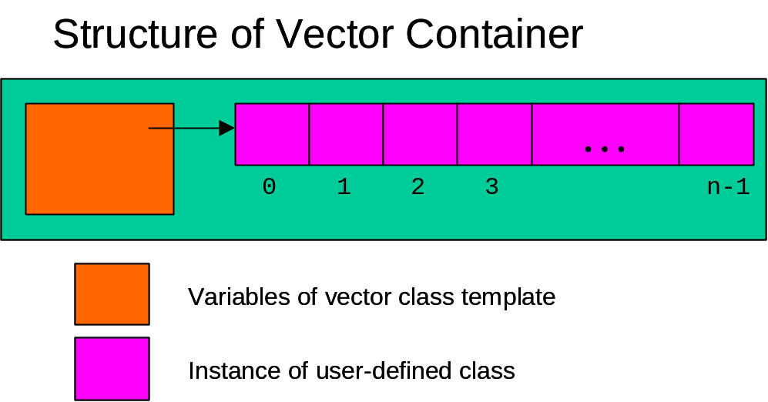

As & when more data elements are added to the vector, dynamic array has to be re-sized to accommodate (i.e. new & lengthy array is allocated, current array’s contents are copied over, and current array is released).

Next sequence container deque can be considered as enhanced version of vector container. In deque, the data elements can be easily inserted and deleted from the front too (i.e. without adjusting all elements of the array). Dynamic array is considered as circular array to enable this, as shown in the following figure:

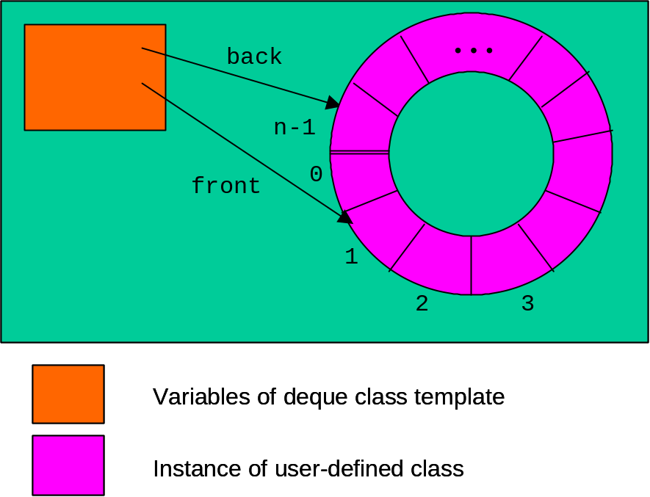

Iterators: While the name iterator and its details may look complicated, basic idea is simple: Since the data elements are buried within the sequence containers, iterator is the special pointer mechanism that is used to navigate through the data element list. Note that the vector is a simple & special container, in which an integer index can be used to loop through the contents. However, for all other containers, iterator has to be used due to their complexity. Pages 237-243 discuss the type of iterators in detail. Here is the gist of the discussion:
- Random access iterators are the closest to pointers when it comes to functionality.
- Stream iterators istream_iterator and ostream_iterator can be used to input and output the data element list from & to particular stream (screen or file etc.)

Algorithms: There are several generic algorithms available in STL. This chapter provides a preview by explaining one such algorithm copy in pages 229-233. As the name implies, this algorithm can be used to copy a part of container into another container, or to output it.

